On the NAGIOS_SERVER

Install libcrypt and nsca and configure.

Note: We are going to use the nagios check_dummy plugin thaqt comes with the plugin distribution.

Add into services.cfg

define service{
use generic-service
service_description Application
active_checks_enabled 0
passive_checks_enabled 1
flap_detection_enabled 0
register 0
is_volatile 0
check_period 24x7
max_check_attempts 1
normal_check_interval 5
retry_check_interval 1
check_freshness 1
freshness_threshold 1500
contact_groups YOUR_CONTACT_GROUP
notification_interval 120
notification_period 24x7
notification_options w,u,c,r
stalking_options w,c,u
name Application
}

define service{
use Application
service_description System EventLog
host_name YOUR_HOSTNAME
check_command check_dummy!0
}

On YOUR_HOSTNAME
Install nagios event log service
Launch nagios event log control manager

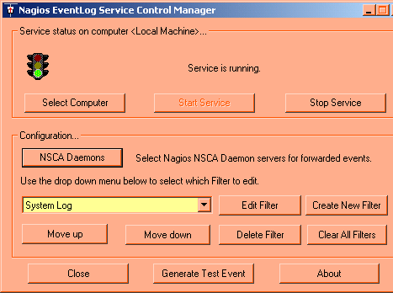

Click NSCA configure daemons

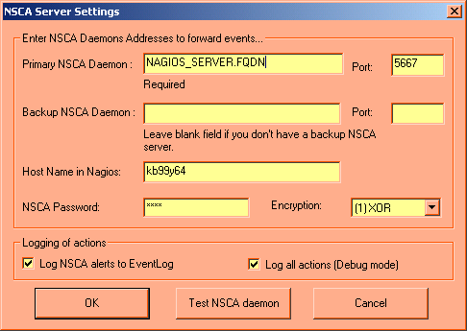

Click Test NSCA Daemon

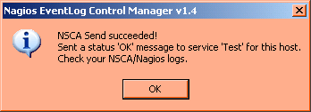

Click Generate Test Event

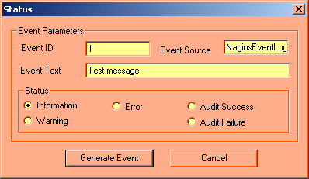

Check Status as Warning

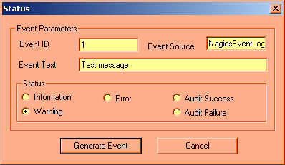

Click Generate Event

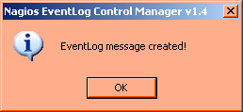

On the NAGIOS_SERVER

Tail /var/adm/messages

May 23 15:46:49 gbrslo02ux003 nsca[1731]: [ID 879649 daemon.info] Handling the connection...
May 23 15:46:49 gbrslo02ux003 nsca[1731]: [ID 691272 daemon.notice] SERVICE CHECK -> Host Name: 'kb99y64', Service Description: 'System EventLog', Return Code: '1', Output: 'Application [warning] [nagioseventlog test #1]: Test message '
May 23 15:46:49 gbrslo02ux003 nsca[1731]: [ID 862360 daemon.error] End of connection...
May 23 15:46:49 gbrslo02ux003 nsca[1731]: [ID 691272 daemon.notice] SERVICE CHECK -> Host Name: 'kb99y64', Service Description: 'System EventLog', Return Code: '1', Output: 'Application [warning] [nagioseventlog test #1]: Test message '
May 23 15:46:49 gbrslo02ux003 nsca[1731]: [ID 862360 daemon.error] End of connection...
May 23 15:46:50 gbrslo02ux003 nagios[2101]: [ID 702911 user.info] EXTERNAL COMMAND: PROCESS_SERVICE_CHECK_RESULT;kb99y64;System EventLog;1;Application [warning] [nagioseventlog test #1]: Test message
May 23 15:46:55 gbrslo02ux003 nagios[2101]: [ID 702911 user.info] SERVICE ALERT: kb99y64;System EventLog;WARNING;HARD;3;Application [warning] [nagioseventlog test #1]: Test message
May 23 15:46:55 gbrslo02ux003 nagios[2101]: [ID 702911 user.info] SERVICE NOTIFICATION: ids;kb99y64;System EventLog;WARNING;notify-by-epager;Application [warning] [nagioseventlog test #1]: Test message

- nagios runs a SERVICE CHECK and spots something coming into its command-file.
- Nagios spots its an EXTERNAL COMMAND: and runs a PROCESS_SERVICE_CHECK_RESULT with the information that was sent across
- This is effectively what the result will look like in nagios

4) If configured, nagios spots a SERVICE NOTIFICATION: and forwards an alert off to in this case a pager.

